Data Driven Fuzzy Membership Function Generation for Student Marks Grading using Statistics Approach

line 1: 1st Paveetheran A/L Thinagaran   
line 2: *Faculty of Information Technology And Communication*  
line 3: *Universiti Teknikal Malaysia Melaka*line 4: Durian Tunggal,Melaka  
line 5: b031910470@utem.edu.my

line 1: 4th Khalid Tewfik Mohamed  
line 2: *Faculty of Information Technology And Communication*  
line 3: *Universiti Teknikal Malaysia Melaka*line 4: Durian Tunggal,Melaka  
line 5: B031810452@student.utem.edu.my line 1: 2nd Hariharan A/L R.Mohan  
line 2: *Faculty of Information Technology And Communication*  
line 3: *Universiti Teknikal Malaysia Melaka*line 4: Durian Tunggal,Melaka  
line 5: b031910477@student.utem.edu.my

.line 1: Dharshen V Sivananda  
line 2: *Faculty of Information Technology And Communication*  
line 3: *Universiti Teknikal Malaysia Melaka*line 4: Durian Tunggal,Melaka  
line 5: shen3997@gmail.com

*Abstract*— Educational systems typically employ classical methods of performance evaluation. In this system, student performance depends on exam results and is evaluated only as success or failure. Alternative, non-classical performance evaluation methods may be used, such as fuzzy logic, a mathematical technique of set-theory that can be applied to many forms of decision-making including research on engineering and artificial intelligence.

This study proposes a new performance evaluation method based on fuzzy logic systems.

Evaluation of the results showed variations between the classical and fuzzy logic methods. Although performance evaluation using fuzzy logic is complicated and requires additional software, it provides some evaluation advantages. Fuzzy logic evaluation is flexible and provides many evaluation options, while the classical method adheres to constant mathematical calculation. At the application stage, the teacher responsible for the laboratory application can edit the ranges of membership functions and rules, permitting non-homogenous but flexible and objective performance evaluation

Keywords—

# Introduction

Measurement of educational performance is usually expressed numerically, based on examination results. Classical evaluation therefore consists of a judgment based on the comparison of student results against established performance-criteria. Measurement and evaluating are inspirable and important parts of the educational process. Evaluating student exam scores is performed using various methods.

During the twentieth century Fuzzy logic theory has emerged and was predicted to be applied extensively in many fields (Altrock, 1995) by the beginning of the twenty-first century. One of the applications of the fuzzy logic theory is the measurement and evaluation in education. In this context, the aim of this paper is to define the “impact of the fuzzy logic theory on the measurement of student’s performance” (Semerci, 2004).

# Methods

## Study Group

The study used exam scores which 100 students took test preparation course, has parental level of education and their test scores such as maths, reading and writing.

## Aim Of Study

The aim of the study is to determine students’ performance using a fuzzy logic model in place of classical assessment methods. The study aimed to address the following research questions:

1. Is there any difference between classical and fuzzy logic evaluation methods?

2. Is there any difference in assessment results between classical and fuzzy logic evaluation methods?

*C*. *Fuzzy Logic*

In 1965 as a mathematical way ,the fuzzy logic set was introduced to represent linguistic vagueness (Zadeh, 1965). Factors and criteria can be classified without certain limits according to the fuzzy logic concept. For addressing real-world problems, fuzzy logic can be very helpful which usually involve a degree of uncertainty. The modeling of many systems involves the consideration of some uncertain variables. The statistical uncertainties associated with these variables are handled through probability theory. There also exists non-statistical uncertainty (in the form of ‘vagueness’ or ‘imprecision’) associated with many variables. These variables and their influences on the system are defined in linguistic terms. This form of uncertainty can be handled in a rational framework of ‘fuzzy set theory’. It can be said that probability deals with statistical uncertainty, whereas fuzziness has been introduced as a means of representing and manipulating non-statistical uncertainty (Bezdek, 1994). Fuzzy logic uses variables like “low”, “normal”, ”high” in place of ”yes/no” or ”true/false” variables. Fuzzy sets are determined by membership functions. The membership function of a fuzzy set is expressed as ȝA(x) and membership degree of its fuzzy set is determined as a number between 0 and 1. If factor x definitely belongs to set A, ȝA(x) is 1 and if it definitely does not belong to set A, ȝA(x) is 0. A higher membership function value (up to a value of 1) shows that factor x has a stronger degree of membership to set A (Mathworks, 2009; Timothy, 2004; Zimmermann, 2001). Boundary conditions of the membership function can be expressed with flexible structure in fuzzy sets. The most significant difference between traditional sets and fuzzy sets is the membership function. While traditional sets can be characterized by only one membership function, fuzzy sets can be characterized by numerous membership functions (ùen & Cenkçi, 2009).

# Data Driven Steps For Generating Student Grading Membership Functon

On this section will discuss more details regarding generate those membership function using statistics approach with existing dataset to be used in this method. To generate the Membership Function will have followed by Step 5 to achieve the goal which is membership function for it. Step 1 is to generate the initial prototype, Step 2 is refining generated prototype, Step 3 is generating the initial membership function, Step 4 is to optimize and remove unwanted membership function and Step 5 is refining generate membership function. Those steps are to make the membership function more efficient and output data will accurate.

In step 1 is to generate the initial prototype. First , need to normalized the dataset between 0 to 1.Then need to analysis the dataset for a column which is the identify the sample mean $\overline{X_{data}}$, minimum $\min_{data}$, maximum $\max_{data}$ and standard deviation ${sigma}_{data}$ will be the first prototype. The one sample t-test was used to identify the data that are significantly different from the mean to generate secondary prototype.

$$t=\frac{\overline{X}- μ}{\frac{S}{\sqrt{n}}} (1)$$

where , $\overline{X}$ is sample mean, $μ$ is population mean, $s$ and $n$ are the standard deviation and sample size. Using t-distribution table on $α=0.2$ on identify the p-value (critical value) .If the t value is greater than the p-value then the null hypothesis is rejected.

Using the Student t-test for unequal sample size and unequal (2), two prototype to the left and right are generated using the sample mean in the first prototype.

$$t\left(\overline{X_{1}}, \overline{X_{2}}\right)= \frac{\overline{x_{1}}- \overline{x_{2}}}{\sqrt{\frac{s_{1}^{2}}{n_{1}}+\frac{s_{2}^{2}}{n_{2}}}} (2)$$

|  |  |
| --- | --- |
| $${PM}_{L}=\max\left(x\right):$$ $0<x< \overline{X_{data}}$, $$t\left(\overline{X_{ 0,x}}, \overline{{X }_{data}}\right)> t_{critical}$$ | (3) |
| $${PM}_{L}= \overline{x_{0,{PM}_{l}}}$$ | (4) |
| $${PM}_{R}=\max\left(x\right):$$ $\overline{X_{data}}<0<1$, $$t\left(\overline{X_{ 1,x}}, \overline{{X }_{data}}\right)> t_{critical}$$ | (5) |
| $${PM}_{R}= \overline{x_{0,{PM}_{l}}}$$ | (6) |

where, ${PB}_{L}$ and ${PM}_{L}$ are two secondary prototype to the left of the sample mean and ${PB}_{R}$ and ${PM}_{R}$ are two secondary prototype to the right of the sample mean. The Student t-test occur on this formula to identify data significantly different from the initial prototype. Those formula which mention need to change in coding in mat lab to generated.

In Step 2 is the refine initial prototype generate. In here, need identify the similar prototype and combined it. So, it’s will optimize and makes the works easy to implement to membership function on following step. Besides that, can increase the efficient data output. Prototype within $ε$ range of each other are averaged.

$$∀i ≠j ∈k,P_{n}= \frac{P_{i}+P_{j}}{2} ⇒ \left|P_{i}+P_{j}\right|< ϵ (7)$$

Where $k$ is the set of generated prototypes, $P_{i}$ and $P_{j}$ are prototypes $P_{n}$ is the new prototype and $ε$ is a present constant, and | | denotes the absolute value. Prototype within $ε$ of min and max values are removed, holding only the min and max values. The purpose to create this because intake data extremes need to be prototype of some membership function.

$$P_{i}= \min_{data} ⇒\left|P_{i}- \min_{data}\right|< ε (8)$$

$$P_{i}= \max_{data} ⇒\left|P_{i}- \max_{data}\right|< ε (9)$$

Lastly on step 2, the balance prototype is clustering separation property.

$$∀i∈k,\left|P_{i}-P_{i+1}\right|< η⇒G_{m}=\left\{P_{i},P_{i+1}\right\} (10)$$

$$∀i∈k,\left|P_{i}-P_{i+1}\right|≥ η⇒G_{m}=\left\{P_{i}\},G_{m+1}\{P_{i+1}\right\} (11)$$

Where *G* is set of prototype.

In step 3 is generate initial membership function. The cores of the membership function are defined using the minimum and maximum prototype of a group *G*

$$C_{L,i}=\min\left(P_{j}\right)∀P_{j} ∈ G_{i};i=1,2,…..M (12)$$

$$C_{R,i}=\max\left(P_{j}\right)∀P_{j} ∈ G_{i};i=1,2,…..M (13)$$

Where *i* is the generated MF and M is the set of generated group in Step 3. The support of the $i^{th}$ membership function.

$$S_{L,i}=\max\left(P_{j}\right)∀P_{j} ∈ G_{k}: P_{j}< C_{L,i};k=1,…M (14)$$

$$S_{R,i}=\min\left(P_{j}\right)∀P_{j} ∈ G_{k}: P_{j}> C_{R,i};k=1,…M (15)$$

The left support of the $i^{th}$ membership function $S_{L,i}$ is the prototype to immediate left of the left core $C_{L,i}$ and similarly the right support $S_{R,i}$ is the prototype to the immediate right of the right core $C_{R,i}$.

In Step 4 is to remove unwanted membership function to increase the student grading accurate. Average student grading is defined for fuzzy system which is used to identify membership function that will be removed unwanted. The average student grading, *AU* is defined in terms of normalized dissymmetry and normalized degree of compliance because metrics are already fulfilled

$$AU= \left(\frac{\sum_{i=1}^{M}{\overline{{diss}_{i}}}}{M}+\frac{\sum_{i=1}^{M}{\overline{{comp}_{i}}}}{M}\right)÷2 (16)$$

Where M is the number of membership function in the system, and AU is the averaged student grading.

Where a membership is deleted, the prototype that were used to generate the core of the membership function are also deleted. For certain occasions detailed below, membership function is combined. This is done by creating a new membership function by defining the core as the leftmost and rightmost prototypes of the MFs that are combined.

$$C_{L,n}=\min\left(P_{k}\right)∀P_{k}∈ G_{i},G_{j} (17)$$

$$C_{R,n}=\max\left(P_{k}\right)∀P_{k}∈ G_{i},G_{j} (18)$$

where, *i* and *j* are the membership function that are being combined and n is the new MF that is generated.

The membership function generated using minimum and maximum prototypes of data are not deleted. The remaining membership function are deleted or removed as follows: remove membership function that increase *AU* while the number of membership function is greater than $ω$. If the number of membership is still greater than Ω then identify membership that reduces *AU* the least, and combine it with the closest membership function using (32) and (33), until the number of membership function is less than or equal to Ω. The constants $ω$ and Ω are preset such that $2 ≤ ω≤Ω$. This ensures that the generated fuzzy system contains at least $ω$. Membership function and less than or equal to Ω membership function.

Step 5 is the spread of the remaining MFs are adjusted to fulfill criteria Dataset Coverage, Threshold value for intersection points, Complementarity and Threshold.

# EXPERIMENTAL RESULT

On this section we can conclude the workings of the step that defines the prototypes to create the membership functions as well. After the success of finding the 1st prototype, the ways needed to be done to the second prototype as well. After many complex ways, finally the second prototype is successfully created as well.

## Authors and Affiliations

|  |  |
| --- | --- |
| Paveetheran A/L Thinagaran | *Accesing workings on MATLAB, source findings and report finding* |
| Hariharan A/L R.Mohan | *Accssing workings on EXCEL, source findings and report finding* |
| Dharshen V Sivananda | *Accessing works on video editing, source findings and report finding* |
| Khalid Tewfik Mohamed | *Report finding* |

## Identify the Headings

From the solutions on the 1st and 2nd prototype, we are using different methods to identify the output as well. For example, other teammate using MATLAB to retrieve the data by getting the information and plotting the graph as well and other teammate using EXCEL to retrieve data by using stat analysis tool pack as well.

## Figures and Tables

#### The subsampling data tables that we retrieve for our project.

|  |  |  |
| --- | --- | --- |
| Math score | Reading score | Writing score |
| 70 | 97 | 82 |
| 63 | 47 | 88 |
| 76 | 31 | 67 |
| 94 | 46 | 79 |
| 75 | 66 | 80 |
| 78 | 59 | 36 |
| 60 | 80 | 60 |
| 87 | 67 | 76 |
| 47 | 60 | 41 |
| 18 | 83 | 76 |

1. The subsample data to make the prototype and the membership function.

#### THE PROTOTYPE OF MATH SCORE

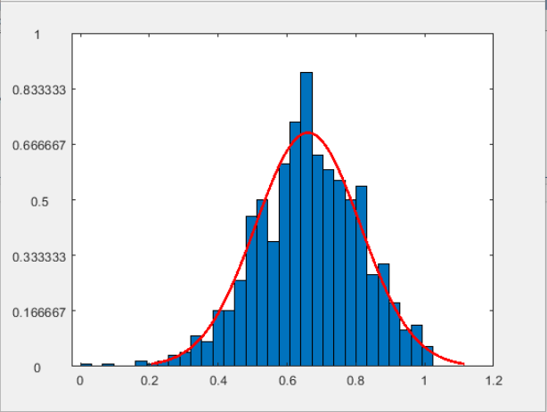

Fig. 2. The prototype of Math Score

#### THE DATA OF 2ND PROTOTYPE OF MATH SCORE

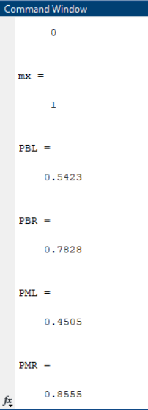

Fig. 3. The data of 2nd prototype of Math Score

#### THE PROTOTYPE OF READING SCORE

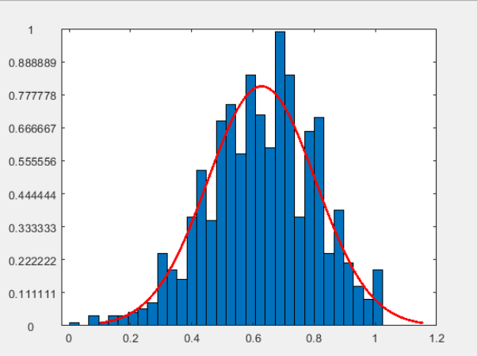

Fig. 4. The prototype of Reading Score

#### THE DATA OF 2ND PROTOTYPE OF READING SCORE

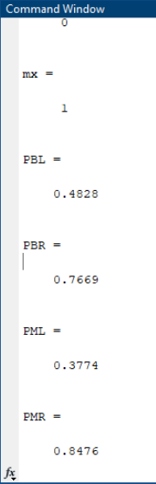

Fig. 5. The data of 2nd prototype of Reading Score

#### THE PROTOTYPE OF WRITING SCORE

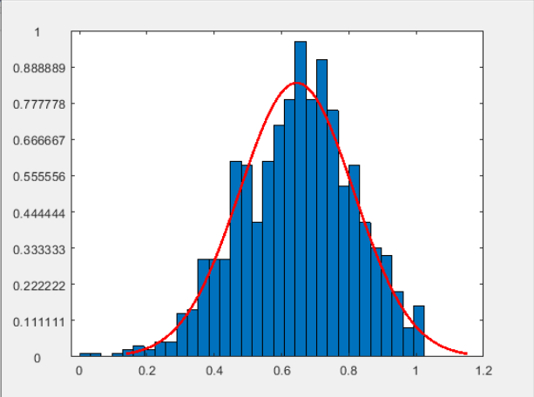

Fig. 6. The prototype of Writing Score

#### THE DATA OF 2ND PROTOTYPE OF WRITING SCORE

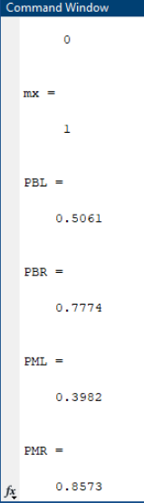

##### References

1. Chen, G. (2001). Introduction to Fuzzy Sets, Fuzzy Logic, and Fuzzy Control Systems. Houston, Texas: CRC Press LLC.
2. Hooda, D. S. (2017). Fuzzy Logic Models and Fuzzy Control An Introductio. Oxford, U.K: Alpha Science International Ltd.
3. Klir, G. J. (1995). Fuzzy Sets and Fuzzy Logic Theory and Applications. Upper Saddle River: Prentice Hall PTR.
4. Mandal, S. (2019). Statistical Application for Landslide Susceptibility Assessment and Prediction. Sarisha, West Bengal, India: Springer.
5. Prof. Dr. Dr. h.c. Hans-Jiirgen Zimmermann, E. (1998). Uncertainty Analysis in Engineering and Sciences: Fuzzy Logic, Statistics, and Neural Network Approach. Aachen, Germany : Springer .

**GOOGLE DRIVE LINK:-**

**https://drive.google.com/file/d/1lZJEhKtVre-3BMm_YAeq2MqM8a859lAB/view?usp=drivesdk**

Fig. 7. The data of 2nd prototype of Writing Score